**Contents**

Appendix 1 Action Group Sample Letter of Invitation 1

Appendix 2 Presentation: What Is An Age Friendly Town 3

Appendix 3 Terms of Reference for an Age Friendly Town Action Group 4

Appendix 4 Identifying what area to cover 5

Appendix 5 Sample Letter for Local Representatives 7

Appendix 6 Sources of Funding 8

Appendix 7 Branding Guidelines 10

Appendix 8 Effective use of the media 10

Appendix 9 Key elements of a press release 12

Appendix 10 Template for Mapping the Town’s Assets 13

Appendix 11 Example of a completed asset map: Ardee 15

Appendix 12 Age Friendly On-Street Survey 17

Appendix 13 Age Friendly On-Street Survey – Self Completion 21

Appendix 14 Example of analysis of on-street surveys: Cavan 26

Appendix 15 Example of a walkability route: Cavan 28

Appendix 16 Walkability audit: Information form 29

Appendix 17 Age Friendly Ireland - Walkability Audit 30

Appendix 18 Public Consultation Questions and recording template 39

Appendix 19 Public Consultation Presentation 44

Appendix 20 Template for Age Friendly Town Action Plan 45

Appendix 21 Examples of background information 48

Appendix 22 Example of what have people told us: Raheny 50

Appendix 23 Section of an Age Friendly Town Action Plan: Cavan 2014 51

## Appendix 1 Action Group Sample Letter of Invitation

INSERT ADDRESS

XXXXXX  
XXXXXX  
XXXXX

INSERT DATE

Re: INSERT TOWN Age Friendly Towns Programme

Dear INSERT NAME,  
We are forming a group of people interested in INSERT TOWN becoming a better place for people to grow old in. We will do this by taking INSERT TOWN through the Age Friendly Towns Programme, an initiative which is part of the national Age Friendly Cities and Counties (AFCC) programme operational in all local authorities in Ireland. As of June 2015, there were 22 Age Friendly Towns throughout Ireland, and this number is growing.

An Age Friendly Town benefits people of all ages. Many of the key determinants of the quality of life are determined at local level, and quite often small improvements make a significant difference.

We would like to invite you to become a member of our Action Group. We believe that your contribution would be a huge benefit as we work towards INSERT TOWN becoming truly age friendly.

We propose that the Action Group will meet INSERT FREQUENCY HERE – every 4-6 weeks is recommended during the programme to manage the initial consultation with people about the town, to create an action plan to improve the town and then to monitor and make sure that the actions take place and that INSERT TOWN gets national recognition for becoming age friendly. In other towns this process has taken around two years. You can find background information on the Age Friendly Towns Programme and see individual town reports and videos on the [www.agefriendlyireland.ie](http://www.agefriendlyireland.ie) website.

We hope that you will join us in this locally-driven initiative. The first meeting of the Age Friendly Action Group will take place in INSERT VENUE at INSERT TIME/DATE. You can call me INSERT YOUR NAME on INSERT NUMBER to let me know if you are interested and able to attend the first meeting. I will be happy to answer any questions you might have about the Age Friendly Towns Programme.

Kind regards, YOUR NAME

## Appendix 2 Presentation: What Is an Age Friendly Town?

## Appendix 3 Terms of reference for an Age Friendly Town Action Group

**Definition**

An Age Friendly Town Action Group is the driver for the creation of an age-friendly town. The Action Group reflects on the concerns and experiences of people in the town, as expressed in consultation activities, and creates and agrees an action plan aimed at improving the town for older people.

**Purpose of the group**

* To create an age friendly town by following the Age Friendly Town Programme.
* To consult with local older people to find out what changes are needed to make the town a better place in which to grow old
* To devise an Age Friendly Town Action Plan with owners and timelines to document the necessary changes.
* To work with the local authority and other local service providers to implement the Age Friendly Town Action Plan.
* To monitor and review the Age Friendly Town Action Plan.
* To gain recognition as an Age Friendly Town from Age Friendly Ireland.

**Membership**

Individuals and group representatives can be members, so long as they are representative of the diversity of the community and/or key agencies and services for older people locally.

**Meetings**

Regular Action Group meetings involve members taking on specific responsibilities, including chairperson, secretary and treasurer. When decisions cannot be reached by consensus, a two-thirds majority is required. Agendas are circulated before meetings.

**Terms of office**

The full cycle of an Age Friendly Town Programme is about two years. To ensure consistency, members are asked to commit for the duration of the programme.

## Appendix 4 Identifying what area to cover

The CSO website has an area profile of most towns in Ireland. This shows the boundary and provides demographics, a breakdown by age and other useful statistics about the town. You can search for your town and data from the Census 2011 on <http://census.cso.ie/areaprofiles/> The Pobal website includes maps showing age dependency ratios and other interesting information about who lives in an area and their potential needs.

To access local electoral districts:

* go to <http://maps.pobal.ie/#/Map>
* zoom in on your town
* select Boundaries
* then select Electoral Divisions
* select your town or urban village.

You will now have an outline map of the area which you can save and print.

If you want to use an area instead of Electoral Divisions, choose the “Small (Local) Area” category.

To see Pobal’s excellent maps showing age dependency ratios:

* go to <http://maps.pobal.ie/#/Map>
* select 2011 data by Small Area (see above)
* choose Age Dependencies Ratios

You can now see the areas in which higher numbers of older people live.

Pobal has a maps user guide which can help you to navigate the website. You can access it at <http://maps.pobal.ie/Documents/FAQ.pdf>

The CSO’s census website <http://census.cso.ie/sapmap/> contains data on population age and trends, disability rates and numbers of carers. You can also look at the data for your town to see how it compares with national statistics.

To access this information, use the small area codes found on the Pobal website. The CSO website’s help button <http://census.cso.ie/sapmap/help.htm> can guide you round the site.

Once you’ve agreed the boundary of the area to be covered in your Age Friendly Town Programme, detailed street maps can be printed from <https://www.google.com/maps> .

## Appendix 5 Sample Letter for Local Representatives

INSERT ADDRESSXXXXXX  
XXXXXX  
XXXXX

INSERT DATE

Re: INSERT TOWN Age Friendly Towns Programme

Dear INSERT NAME,  
  
We are writing to let you know that we have formed a group of interested people who would like to make INSERT TOWN a better place for people to grow old in. We will do this by taking INSERT TOWN through the Age Friendly Towns Programme, an initiative which is part of the national Age Friendly Cities and Counties (AFCC) programme operational in all local authorities in Ireland.

We are very excited about this programme and think that it will be a huge benefit to all people living in INSERT TOWN. As of June 2015, there were 22 Age Friendly Towns throughout Ireland, and this number is steadily growing. An Age Friendly Town benefits people of all ages. Many of the key determinants of the quality of life are determined at local level, and quite often small improvements make a significant difference.

A key feature of the Age Friendly Towns Programme is collecting people’s views about what the town is like as a place to live and how it could be improved. We will be collecting data by doing on-street surveys, walkability audits with groups of people around the town, talking to influential people, such as yourself, and also holding public consultation meetings.

As someone who is concerned with the future of INSERT TOWN we feel sure that you will be able to see the benefits of the Age Friendly Town Programme. If you would like to be more involved in any of this, please let me know. You can contact me on INSERT NUMBER or INSERT EMAIL ADDRESS. You can find out more about the Age Friendly Towns Programme by visiting [www.agefriendlyireland.ie](http://www.agefriendlyireland.ie).

I will look forward to hearing from you.

Kind regards,

YOUR NAME

## Appendix 6 Sources of funding

**Community Foundation of Ireland;** Among other grants they run the Older Persons’ Fund, a long term philanthropic fund which promotes the civic engagement of older people.

<http://www.foundation.ie/apply-for-a-grant/types-of-grant/the-older-persons-fund/> -

**HSE National Lottery grants:** The National Lottery generates funds for good causes in the areas of Youth, Sport, Recreation and Amenities, Health & Welfare, Arts, Culture & National Heritage and the Irish Language. The Department of Health runs the National Lottery Discretionary fund, which provides once-off grants to organisations for the provision of health-related services. The fund is aimed at community groups and voluntary organisations operating in Ireland providing health services to specific client providing information and support for various disabilities and illnesses or groups with a specific interest.

[www.hse.ie/lotterygrants](http://www.hse.ie/lotterygrants)

**Age & Opportunity:** The Small Grant Scheme is a joint initiative between Age & Opportunity’s Go for Life programme and Sport Ireland. Grants are available to eligible local clubs, groups and organisations that promote increased participation in recreational sport or physical activity for older people as a main element of their activities. A total of €300,000 will be available in grants in 2015. This year grants will be between €250 and €700.

<http://ageandopportunity.ie/what-we-do/physical-activity-sport/go-for-life-grant-scheme>

**The Ireland Funds:** The Ireland Funds are committed to supporting elderly Irish men and women by funding organisations that provide access to a wide range of services and educational opportunities that tackle loneliness and isolation and that develop strong social networks through day centers or social clubs.

<http://www.theirelandfunds.org/overview>

**ESB Community and Sponsorship grants:** Grants are allocated on a quarterly basis. Most grants are in the order of €10,000, though some larger grants are also available. They support registered charities, not for profit organisations and community and voluntary groups. Projects must fall under either or both the following areas: ‘Care of the homeless’ and ‘Suicide prevention and counselling’.

<https://www.esb.ie/main/community-sponsorship/apply-for-a-grant.jsp>

**Pobal** manages a wide variety of programmes on behalf of the Irish Government and EU bodies. You can explore the options on their web site:

<https://www.pobal.ie/FundingProgrammes/Pages/Current.aspx>

**Activelink,** an online network for Irish non-profit organisations, provides information on community-level funding schemes: <http://www.activelink.ie/content/community-exchange>

## Appendix 7 Branding Guidelines

Age Friendly Ireland has developed a brand that represents the Age Friendly Programme which is clear, colourful and relates to the core objective of the programme.

The brand comprises an image of 8 coloured petals, each one representing a theme of the WHO Age Friendly Cities Network - outdoor spaces and buildings; transportation; housing; social participation; respect and social inclusion; civic participation and employment; communication and information; and community support and health services. The brand also includes the tagline: Ireland; a great country in which to grow old. This tagline encapsulates the aim of the programme and complements the visual element of the brand. This image and tagline combined create a most impactful brand that is gaining recognition across the country at speed.

**Logos**

Once agreement has been reached to adopt the programme, each town will receive its own Age Friendly Town logo for use throughout the lifetime of the programme. (See sample logo below)

The Age Friendly logo should appear on all materials produced under the auspices of the programme, i.e. Consultation documentation, posters, Action group meeting documentation and action plan. The logo should also appear on materials directly linked to the programme, or entered into in collaboration with other partner organisations in the area.

All logos are designed centrally in the interest of maintaining brand consistency across the programme. Guidelines for the use of logos are available from the Age Friendly Ireland office. A generic ‘Ireland’s Age Friendly Cities and Counties Programme’ logo is available for use for initiatives or publications which are not specific to the programme in one county.

## Appendix 8 Effective use of the media

Local radio and local newspapers are great ways of publicising your efforts to make your town age friendly. To use the media effectively, you need to know:

* who to contact
* what the deadlines are
* how to present the material in the right way.

**How best to use local radio**

Local radio offers a powerful means of building a profile for your activities.

**Getting started with local radio**

* Do some basic research on your local station. Most stations have websites which detail the types of programmes they broadcast. This will give you a good idea of what they are interested in.
* Presenters are not necessarily the most important decision makers on a radio station. Producers and researchers are generally the people who make the decisions about what topics are covered, and how. Put together a list of key contacts by phoning the station or checking their website.
* Contact the people you have identified to find out how they prefer to receive information, for example by post, phone, email or fax. Also, find out how much lead-in time they need before deadlines. Always send in your information well in advance.
* Emphasise the local interest of your material, and that it is part of a national programme.
* Make sure the information you send is concise and clear. Always include a contact telephone number and email address and, for events the date, start and end times and venue. Mention any local representatives or public figures who may attend an event.
* Nominate an articulate older person who is involved in the Action Group and who could represent you in radio interviews and call-in shows.

**Getting mentioned in local newspapers and newsletters**

* Identify editors of the local social or events column of your local newspaper.
* Make sure the information you send is concise and clear. Always include a contact telephone number and email address and, for events, the date, start and end times and venue. Who is your target audience? Mention any local representatives or public figures who may attend an event.
* Emphasise the local interest of your material, and that your activities are part of a national programme.

## Appendix 9 Key elements of a press release

* All the most important information should be in the first paragraph. The rest can be explanation.
* Be clear: who, why, what, when, where and how.
* Have a snappy headline which accurately sums up your message.
* Include a quotable quote.
* Include contact details.
* Put the date on which it was issued at the top and bottom of the press release.

**Sample press release**

**Insert Date**

**OLDER PEOPLES’ VOICES WILL MAKE (INSERT TOWN) A GREAT PLACE TO GROW OLD IN**An Age Friendly Town is a town where the community understands and responds to the needs of older people. Over the coming months INSERT TOWN will be working to engage and consult with the local community as part of the Age Friendly Town Programme. We would like you to come and express your views. The aim is to significantly improve the quality of life of older adults living in the area and to engage them in shaping and enhancing their own communities. The process involves consulting with older people and key agencies on what the issues are in INSERT TOWN. From what is heard from people an Action Plan will be developed with actions agreed to improve INSERT TOWN.

By June 2015 twenty two towns had already become Age Friendly in Ireland and many improvements have been made as a result of the Age Friendly Town programme. Simple things such as more benches, a community garden, the changing of traffic signalling to allow more time for people to cross the road or linking up bus routes to the hospital have happened as a result of recent programmes.

(INSERT name of Action Group chairperson) said: “We will be spending the coming number of months engaging with and listening to older people across INSERT TOWN. We want to know what matters to the older members of our communities on issues such as public transport, access to quality healthcare, opportunities to socialise and stay connected, and public spaces where people can walk and talk and feel safe.”

The Age Friendly Town Programme is part of the wider national programme, the Age Friendly Cities & Counties Programme which is working to make Ireland one of the best places in the world in which to grow old. The Programme aims to see all older people living in Ireland enjoying a good quality of life and participating fully in their communities.

**END**

For more information on the Age Friendly Town Programme, please contact INSERT CONTACT NAME AND NUMBER HERE OF A MEMBER OF AGE FRIENDLY TOWN ACTION GROUP

## Appendix 10 Template for Mapping the Town’s Assets

|  |  |
| --- | --- |
| **Name of town** | |
| **Organisation/service** | **Contact details, location, services provided** |
| HSE |  |
| Gardaí |  |
| Community organisations | e.g. Crosscare, St Joseph’s, St Vincent de Paul |
| Local businesses with age friendly focus |  |
| Parks and recreational open spaces |  |
| Community initiatives and facilities | e.g. swimming pools, community halls with knitting groups, Tai Chi, whist drives |
| Heritage | For example, Walled Town, Castle – Castle Street, Abbey |
| Parish churches/places of worship | Often a place older people gather, some offer community facilities to meet |
| Older people’s groups |  |
| Day care centres |  |
| Supported housing |  |
| Residential care centres for older people |  |
| Public transport routes and services |  |
| Schools and third level institutions |  |

## Appendix 11 Example of a completed asset map: Ardee

|  |  |
| --- | --- |
| **ASSETS IN ARDEE** | |
| **Gardai** | Gardai have a list of older venerable people at risk in the community but they cannot access an in-depth list of all people over 65 in Ardee – lack of information available to Gardai.  A Garda patrols the community on bicycle from 2-6pm every-day. |
| **Health Care** | 2 General Practices - John’s Street, Market Street.  Proposed Primary Care Centre in St. Bridget’s Complex. |
| **Sports facilities** | * Gym and sauna in Rugby club – not accessible to general public * Tennis Club * St. Mary’s Gaelic Club * Ardee Celtic Football * Ardee Athletic Club * Angling Club * Ardee Golf Course * Gym in Industrial Units on John Street * Playground & MUGA- Fairgreen Park * Tennis Courts – Community School |
| **Open Space** | * Riverside Park * Dee Valley Walk * Millennium Park and College Green * Mulladrillen Hill * Red House * Fairgreen Park * Railway Way Walk |
| **Community facilities** | * Library – Market Square * Community Centre – Moorehall Road * Ardee Concert Band – on Kells Road. * Community Centre in Moorehall Retirement Village. |
| **Heritage** | * Walled Town * Ardee Castle – Castle Street * Castleguard * Ferdia and Cuchulann Statue |
| **Religious Institutions** | * Church of Our Lady and Nativity – Drogheda Road * Church of Ireland – Market Street |
| **Retirement Groups** | * Ardee Active retirement * Ferdia Social Group |
| **Other facilities in the Day Care Centre** | * Sensory Garden * Sensory Room * Raised bath * Hairdressing facilities |
| **St. Joseph’s Day Care Centre** | * Sensory Garden * Large Wooded Area * Direct access to town centre via Town Wall Gate into the Day Care Centre |
| **Public Transport** | * Bus services to Dublin, Drogheda, Dundalk, Carrickmacross, Navan, Ballybay etc. |
| **Industrial Areas** | Under-utilised Business Parks in the town:   * John Street Industrial Estate, Ardee. * Ardee Business Park, Dunleer Road, Ardee. * Enterprise Centre, O’Carroll Street, Ardee.   Land zoned and applications granted on the N33 Link Road, north-east of the town.  Opportunity to attract age friendly specialised businesses i.e. monitoring companies/technology for older people. |
| **Schools** | 3 Primary Schools and 1 Secondary School – premises could be used after hours. |

Extract from Ardee Age Friendly Town 2012 Report [Age Friendly Towns Ardee Resource Kit](http://agefriendly.ie/louthagefriendly/resources/)

## Appendix 12 Age Friendly On-Street Survey

**How good is your town for older people?**

|  |
| --- |
| Hello. I am involved with the Age Friendly Town Programme. This programme wants to help improve the quality of life for people living in towns and suburbs in Ireland. As part of this we need people to tell us what it is like to live in and visit this town. I have a short questionnaire and I wonder if you would help me by spending a few minutes telling me your views on ________ (*name of town).* You don’t have to answer all the questions and you may stop at any time. Any information we collect will be treated confidentially. |

|  |  |  |
| --- | --- | --- |
| **1. Are you male or female?** | Male  **🞎** | Female **🞎** |

**2. Which of the following statements most applies to you?**

|  |  |  |
| --- | --- | --- |
| I live in the town  **🞎** | I visit and use the services in the town regularly (minimum monthly)  **🞎** | I rarely visit the town, or this is my first time here  **🞎** * finished |

**3. It is important for us to understand the issues for people of different ages, so I hope you don’t mind answering which of the following groups includes your age?**

|  |  |  |  |  |  |
| --- | --- | --- | --- | --- | --- |
| Under55*  **🞎**  *finished | 55 to 59  **🞎** | 60 to 64  **🞎** | 65 to 74  **🞎** | 75 to 84  **🞎** | 85 +  **🞎** |

**4.How is your health in general?**

|  |  |  |  |  |
| --- | --- | --- | --- | --- |
| Excellent **🞎** | Very Good **🞎** | Good **🞎** | Fair **🞎** | Poor  **🞎** |

**5. How would you rate your quality of life?**

|  |  |  |  |  |
| --- | --- | --- | --- | --- |
| Very poor  **🞎** | Poor  **🞎** | Neither good nor poor  **🞎** | Good  **🞎** | Very good  **🞎** |

|  |  |  |
| --- | --- | --- |
| **6. Town Name?** | ____________________ | **7. Questionnaire Number?** ________  *(unique identifier for analysis)* |

For the following statements, could you say whether you agree or disagree with them? You also have the option to answer don’t know or not applicable, if needed. (Please ✓)

|  |  |  |  |  |
| --- | --- | --- | --- | --- |
| **8. Lead healthier and active lives for longer**  **(Community Support and Health Services)** | **Agree** | **Disagree** | **Don’t Know** | **N/A** |
| I am able to access good quality GP services. | **🞎** | **🞎** | **🞎** | **🞎** |
| There are fitness and exercise classes I could take part in, if I wanted. | **🞎** | **🞎** | **🞎** | **🞎** |
| The cost of any healthcare I need is not a problem. | **🞎** | **🞎** | **🞎** | **🞎** |
| I find it easy to get enough exercise most days. | **🞎** | **🞎** | **🞎** | **🞎** |
| *Note any comments or strongly expressed feelings on this topic:* | | | | |
| **9. Stay living in our own homes and communities (Housing)** | **Agree** | **Disagree** | **Don’t Know** | **N/A** |
| I am confident I will get the supports I need to stay living in my home as I get older. | **🞎** | **🞎** | **🞎** | **🞎** |
| My home could be easily adapted to my needs as I grow older. | **🞎** | **🞎** | **🞎** | **🞎** |
| There is a good sense of community in this area. | **🞎** | **🞎** | **🞎** | **🞎** |
| *Note any comments or strongly expressed feelings on this topic:* | | | | |
| **10. Get to where we need to go to when we need to (Transportation)** | **Agree** | **Disagree** | **Don’t Know** | **N/A** |
| Transport wise it is easy for me to get into the town centre. | **🞎** | **🞎** | **🞎** | **🞎** |
| Public transport gets me where I need to go. | **🞎** | **🞎** | **🞎** | **🞎** |
| It is easy to find parking near the town centre. | **🞎** | **🞎** | **🞎** | **🞎** |
| The price I pay for parking can stop me coming into town. | **🞎** | **🞎** | **🞎** | **🞎** |
| I am happy with the standard of bus stops in town. | **🞎** | **🞎** | **🞎** | **🞎** |
| *Note any comments or strongly expressed feelings on this topic* | | | | |
| **11. Be enabled by the built and social environment (Outdoor Spaces and Buildings)** | **Agree** | **Disagree** | **Don’t Know** | **N/A** |
| I am happy with the number of public benches and rest areas in the town. | **🞎** | **🞎** | **🞎** | **🞎** |
| The footpaths are well maintained in this town. | **🞎** | **🞎** | **🞎** | **🞎** |
| The street lighting is good in this town. | **🞎** | **🞎** | **🞎** | **🞎** |
| Cars parking on footpaths can be a problem. | **🞎** | **🞎** | **🞎** | **🞎** |
|  | **Agree** | **Disagree** | **Don’t Know** | **N/A** |
| There are well-maintained green spaces in the area | **🞎** | **🞎** | **🞎** | **🞎** |
| I am happy with the public toilets in this town*.[1]* | **🞎** | **🞎** | **🞎** | **🞎** |
| There aren’t any good places to go for walks in town. | **🞎** | **🞎** | **🞎** | **🞎** |
| *Note any comments or strongly expressed feelings on this topic:* | | | | |
| **12. Feel and be safe at home and out and about. (Outdoor Spaces and Buildings)** | **Agree** | **Disagree** | **Don’t Know** | **N/A** |
| I would feel safe to go walking in my neighbourhood after dark. | **🞎** | **🞎** | **🞎** | **🞎** |
| I am happy with the Garda presence in this area. | **🞎** | **🞎** | **🞎** | **🞎** |
| I know what to do to stay safe in my own home. | **🞎** | **🞎** | **🞎** | **🞎** |
| I worry a lot about being a victim of crime. | **🞎** | **🞎** | **🞎** | **🞎** |
| I feel safe alone in my home at night. | **🞎** | **🞎** | **🞎** | **🞎** |
| *Note any comments or strongly expressed feelings on this topic:* | | | | |
| **13. Have the information we need to live full lives. (Communications and Information)** | **Agree** | **Disagree** | **Don’t Know** | **N/A** |
| If I wanted to, I would find it easy to find out about local events that are happening. | **🞎** | **🞎** | **🞎** | **🞎** |
| It is difficult to find out what services and entitlements I am eligible for. | **🞎** | **🞎** | **🞎** | **🞎** |
| I have used services, like the library or citizen’s advice office, to find information in the past year. | **🞎** | **🞎** | **🞎** | **🞎** |
| I use the internet to find information. | **🞎** | **🞎** | **🞎** | **🞎** |
| *Note any comments or strongly expressed feelings on this topic:* | | | | |
| **14. Be truly valued and respected (Respect and Social Inclusion)** | **Agree** | **Disagree** | **Don’t Know** | **N/A** |
| I think businesses in town make an effort to make older people feel welcome. | **🞎** | **🞎** | **🞎** | **🞎** |

|  |  |  |  |  |  |  |
| --- | --- | --- | --- | --- | --- | --- |
|  | | | **Agree** | **Disagree** | **Don’t Know** | **N/A** |
| Older people are given opportunities to contribute to the community. | | | **🞎** | **🞎** | **🞎** | **🞎** |
| *Note any comments or strongly expressed feelings on this topic:* | | | | | | |
| **15. Participate in social, economic and public life (Social Participation)** | | | **Agree** | **Disagree** | **Don’t Know** | **N/A** |
| There are opportunities for me to volunteer, if I want to. | | | **🞎** | **🞎** | **🞎** | **🞎** |
| The town has most of the shops and services I need. | | | **🞎** | **🞎** | **🞎** | **🞎** |
| This area has enough clubs and societies to participate in. | | | **🞎** | **🞎** | **🞎** | **🞎** |
| There are plenty of possibilities to be able to mix with other people in this town. | | | **🞎** | **🞎** | **🞎** | **🞎** |
| It would be a benefit to me if there was a drop-in centre for older people to meet and socialise in[2]. | | | **🞎** | **🞎** | **🞎** | **🞎** |
| *Note any comments or strongly expressed feelings on this topic:* | | | | | | |
| **16. Continue to learn, develop and work.**  **(Civic Participation and Employment)** | | | **Agree** | **Disagree** | **Don’t Know** | **N/A** |
| If I wanted to continue learning, there are courses available to me. | | | **🞎** | **🞎** | **🞎** | **🞎** |
| *Note any comments or strongly expressed feelings on this topic:* | | | | | | |
| **17. Now we are almost finished. Can you tell me what you think the town does best for older people?** | **18. Could you now tell me what the town could do better for older people?** | | | | |

**THANK YOU VERY MUCH FOR HELPING WITH THIS RESEARCH**

***The format of this questionnaire is fixed, and should not be altered.***

Appendix 13 Age Friendly On-Street Survey – SELF COMPLETION

**How good is your town for older people?**

|  |
| --- |
| The Age Friendly Town programme is working to improve the quality of life of people living in towns and suburbs across Ireland. As part of this we need people to tell us what it is like to live in and visit this town.  This short questionnaire is anonymous and should take you about 5 minutes to complete. You don’t have to answer all questions and you can stop at any time. Any information we collect will be treated confidentially.  Thank you for helping with our research. |

|  |  |  |
| --- | --- | --- |
| **1. Are you male or female?** | Male  **🞎** | Female **🞎** |

**2. Which of the following statements most applies to you?**

|  |  |  |
| --- | --- | --- |
| I live in the town  **🞎** | I visit and use the services in the town regularly (minimum monthly)  **🞎** | I rarely visit the town, or this is my first time here  **🞎** * finished |

**3. It is important for us to understand the issues for people of different ages. Which of the following groups includes your age?**

|  |  |  |  |  |  |
| --- | --- | --- | --- | --- | --- |
| Under55*  **🞎**  *finished | 55 to 59  **🞎** | 60 to 64  **🞎** | 65 to 74  **🞎** | 75 to 84  **🞎** | 85 +  **🞎** |

**4.How is your health in general?**

|  |  |  |  |  |
| --- | --- | --- | --- | --- |
| Excellent **🞎** | Very Good **🞎** | Good **🞎** | Fair **🞎** | Poor  **🞎** |

**5. How would you rate your quality of life?**

|  |  |  |  |  |
| --- | --- | --- | --- | --- |
| Very poor  **🞎** | Poor  **🞎** | Neither good nor poor  **🞎** | Good  **🞎** | Very good  **🞎** |

Office use only:

|  |  |  |
| --- | --- | --- |
| **6. Town Name?** | ____________________ | **7. Questionnaire Number?** ________  *(unique identifier for analysis)* |

For the following statements, could you say whether you agree or disagree with them? You also have the option to answer don’t know or not applicable, if needed. (Please ✓)

|  |  |  |  |  |  |  |
| --- | --- | --- | --- | --- | --- | --- |
| **8. Lead healthier and active lives for longer**  **(Community Support and Health Services)** | | | **Agree** | **Disagree** | **Don’t Know** | **N/A** |
| I am able to access good quality GP services. | | | **🞎** | **🞎** | **🞎** | **🞎** |
| There are fitness and exercise classes I could take part in, if I wanted. | | | **🞎** | **🞎** | **🞎** | **🞎** |
| The cost of any healthcare I need is not a problem. | | | **🞎** | **🞎** | **🞎** | **🞎** |
| I find it easy to get enough exercise most days. | | | **🞎** | **🞎** | **🞎** | **🞎** |
| *Any other comments you would like to make on this topic:* | | | | | | |
| **9. Stay living in our own homes and communities (Housing)** | | | **Agree** | **Disagree** | **Don’t Know** | **N/A** |
| I am confident I will get the supports I need to stay living in my home as I get older. | | | **🞎** | **🞎** | **🞎** | **🞎** |
| My home could be easily adapted to my needs as I grow older. | | | **🞎** | **🞎** | **🞎** | **🞎** |
| There is a good sense of community in this area. | | | **🞎** | **🞎** | **🞎** | **🞎** |
| *Any other comments you would like to make on this topic:* | | | | | | |
| **10. Get to where we need to go to when we need to (Transportation)** | | | **Agree** | **Disagree** | **Don’t Know** | **N/A** |
| Transport wise it is easy for me to get into the town centre. | | | **🞎** | **🞎** | **🞎** | **🞎** |
| Public transport gets me where I need to go. | | | **🞎** | **🞎** | **🞎** | **🞎** |
| It is easy to find parking near the town centre. | | | **🞎** | **🞎** | **🞎** | **🞎** |
| The price I pay for parking can stop me coming into town. | | | **🞎** | **🞎** | **🞎** | **🞎** |
| I am happy with the standard of bus stops in town. | | | **🞎** | **🞎** | **🞎** | **🞎** |
| *Any other comments you would like to make on this topic:* | | | | | | |
| **11. Be enabled by the built and social environment (Outdoor Spaces and Buildings)** | | | **Agree** | **Disagree** | **Don’t Know** | **N/A** |
| I am happy with the number of public benches and rest areas in the town. | | | **🞎** | **🞎** | **🞎** | **🞎** |
| The footpaths are well maintained in this town. | | | **🞎** | **🞎** | **🞎** | **🞎** |
| The street lighting is good in this town. | | | **🞎** | **🞎** | **🞎** | **🞎** |
| Cars parking on footpaths can be a problem. | | | **🞎** | **🞎** | **🞎** | **🞎** |
|  | | | **Agree** | **Disagree** | **Don’t Know** | **N/A** |
| There are well-maintained green spaces in the area | | | **🞎** | **🞎** | **🞎** | **🞎** |
| I am happy with the public toilets in this town*.*  *(tick non-applicable if no public toilets in the town)* | | | **🞎** | **🞎** | **🞎** | **🞎** |
| There aren’t any good places to go for walks in town. | | | **🞎** | **🞎** | **🞎** | **🞎** |
| *Any other comments you would like to make on this topic:* | | | | | | |
| **12. Feel and be safe at home and out and about. (Outdoor Spaces and Buildings)** | | | **Agree** | **Disagree** | **Don’t Know** | **N/A** |
| I would feel safe to go walking in my neighbourhood after dark. | | | **🞎** | **🞎** | **🞎** | **🞎** |
| I am happy with the Garda presence in this area. | | | **🞎** | **🞎** | **🞎** | **🞎** |
| I know what to do to stay safe in my own home. | | | **🞎** | **🞎** | **🞎** | **🞎** |
| I worry a lot about being a victim of crime. | | | **🞎** | **🞎** | **🞎** | **🞎** |
| I feel safe alone in my home at night. | | | **🞎** | **🞎** | **🞎** | **🞎** |
| *Any other comments you would like to make on this topic:* | | | | | | |
| **13. Have the information we need to live full lives. (Communications and Information)** | | | **Agree** | **Disagree** | **Don’t Know** | **N/A** |
| If I wanted to, I would find it easy to find out about local events that are happening. | | | **🞎** | **🞎** | **🞎** | **🞎** |
| It is difficult to find out what services and entitlements I am eligible for. | | | **🞎** | **🞎** | **🞎** | **🞎** |
| I have used services, like the library or citizen’s advice office, to find information in the past year. | | | **🞎** | **🞎** | **🞎** | **🞎** |
| I use the internet to find information. | | | **🞎** | **🞎** | **🞎** | **🞎** |
| *Any other comments you would like to make on this topic:* | | | | | | |
| **14. Be truly valued and respected (Respect and Social Inclusion)** | | | **Agree** | **Disagree** | **Don’t Know** | **N/A** |
| I think businesses in town make an effort to make older people feel welcome. | | | **🞎** | **🞎** | **🞎** | **🞎** |
|  | | | **Agree** | **Disagree** | **Don’t Know** | **N/A** |
| Older people are given opportunities to contribute to the community. | | | **🞎** | **🞎** | **🞎** | **🞎** |
| *Any other comments you would like to make on this topic:* | | | | | | |
| **15. Participate in social, economic and public life (Social Participation)** | | | **Agree** | **Disagree** | **Don’t Know** | **N/A** |
| There are opportunities for me to volunteer, if I want to. | | | **🞎** | **🞎** | **🞎** | **🞎** |
| The town has most of the shops and services I need. | | | **🞎** | **🞎** | **🞎** | **🞎** |
| This area has enough clubs and societies to participate in. | | | **🞎** | **🞎** | **🞎** | **🞎** |
| There are plenty of possibilities to be able to mix with other people in this town. | | | **🞎** | **🞎** | **🞎** | **🞎** |
| It would be a benefit to me if there was a drop-in centre for older people to meet and socialise in.  *(tick N/A if there is a drop-in centre in the town)* | | | **🞎** | **🞎** | **🞎** | **🞎** |
| *Any other comments you would like to make on this topic:* | | | | | | |
| **16. Continue to learn, develop and work.**  **(Civic Participation and Employment)** | | | **Agree** | **Disagree** | **Don’t Know** | **N/A** |
| If I wanted to continue learning, there are courses available to me. | | | **🞎** | **🞎** | **🞎** | **🞎** |
| *Any other comments you would like to make on this topic:* | | | | | | |
| **17. Now we are almost finished. Can you tell me what you think the town does best for older people?** | **18. Could you now tell me what the town could do better for older people?** | | | | |

**THANK YOU VERY MUCH FOR HELPING WITH THIS RESEARCH**

*The format of this questionnaire is fixed, and should not be altered.*

## Appendix 14 Example of analysis of on-street surveys: Cavan

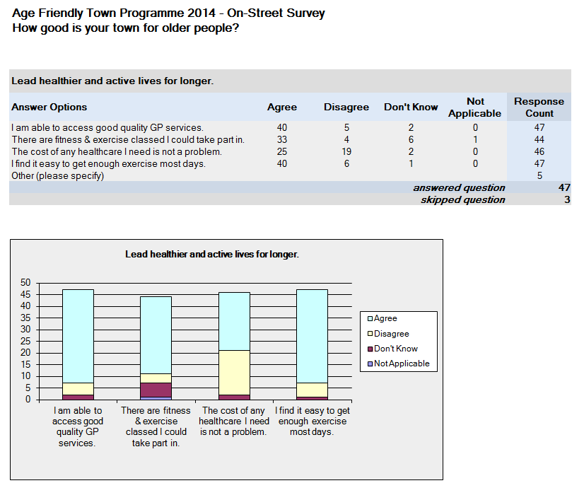

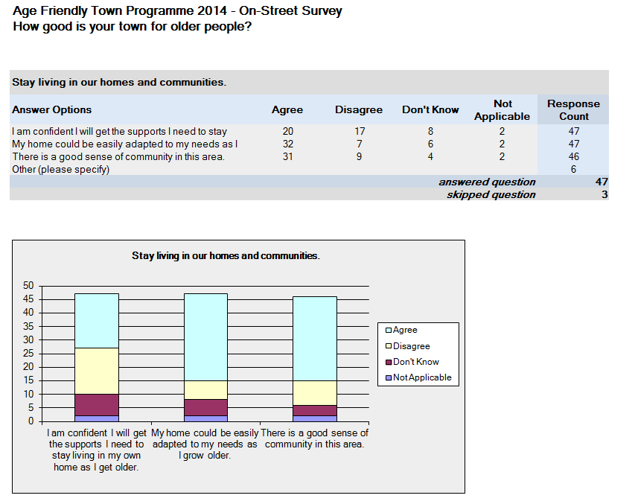

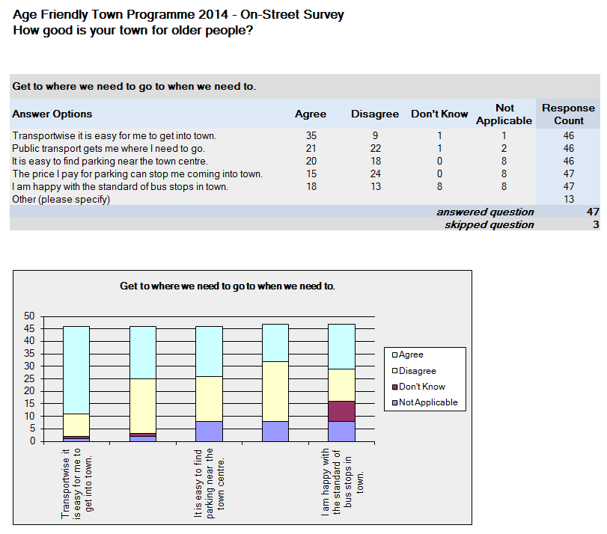Extract from Cavan Age Friendly Town 2014 Report Appendices [Age Friendly Towns Cavan Report](http://agefriendlyireland.ie/wp-content/uploads/2015/03/Cavan_AFT-Final-Report-02.03.15.pdf)

## Appendix 15 Example of a walkability route: Cavan

**Route 2: Cavan Town**

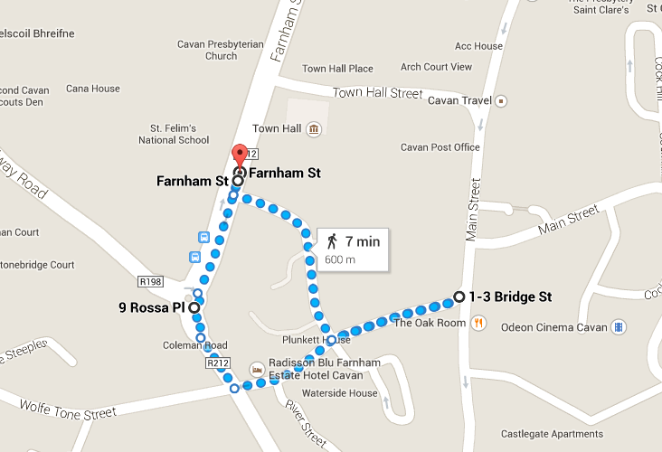

**Directions**

Start/Finish– The Corner of Farnham Street and Abbey Street.

At the corner of Farnham Street and Abbey Street take a left and walk towards Bridge Street. At the Abbey Street/Bridge Street junction take a left and walk towards Main Street. At the Bridge Street/Main Street junction, cross the road and walk back down Bridge Street towards Coleman Road. At the Bridge Street/Coleman Road junction take a right and walk towards Farnham Street/R212 roundabout. From the roundabout walk back towards the corner of Farnham Street and Abbey Street.

Approximate distance 600 meters

Approximate duration 7-10mins

Extract from Cavan Age Friendly Town 2014 Report [Age Friendly Towns Cavan Report](http://agefriendlyireland.ie/wp-content/uploads/2015/03/Cavan_AFT-Final-Report-02.03.15.pdf)

## Appendix 16 Walkability audit: Information form

**Why do the walkability audit?**

A walkability audit assesses how easy or difficult it is to get around your town, and how easy or difficult it is to access services. In a walkability audit, older people and others walk a route to identify and prioritise things that could be improved.

**Who can take part in a walkability audit?**

You! You are here because you are familiar with the town and use and access its services regularly.

**What happens in a walkability audit?**

You will walk in a group with others along a specified route in your town. The walk will be about half a mile (800 metres) long and will take up to an hour to complete.

During the walk we will look at streets, paths, crossings, benches, signage and facilities to see whether they make it easier or harder to walk comfortably along the route. You will be asked to note where there are issues, and discuss what you find with your group. At the end of the walk you will complete a questionnaire which will ask you about what you found when you were walking the route.

**Confidentiality and disclosure of information**

The questionnaires are anonymous. Any information that is obtained in connection with this study and can be identified with you will remain confidential. We plan to publish the results of the study with relevant organisations and journals.

**Photographs**

We will take photographs during the walkability audit. They may be used in documents to illustrate our findings, or may appear in publications, such as Age Friendly Ireland materials, in journals, and in conference presentations. If you do not want your photograph taken please tell the Project Coordinator before starting the walk.

## Appendix 17 Age Friendly Ireland - Walkability Audit

**How walkable is your town?**

|  |
| --- |
| **Guidelines**  Part of being age friendly means promoting active ageing by making sure that towns are easy to get around and that it is easy to access the services and facilities they contain. Use this walkability audit to review what it is like to walk along a specified route in your area.   1. There may be more than one route that you can choose on the day to walk. Select the route you would like to take, some may be longer than others and it takes time to assess the route, so take this into consideration when choosing. 2. While you are out on the streets you will be looking for things that support you to walk, or stop you from walking comfortably along the streets. Take time to note the location of problems and take photos of problems and also things you like. 3. During the walk take time to assess the:  * footpaths: availability, quality, ramped, width, obstacles in the way * crossings: convenience, safety, traffic lights * aesthetics: signage, litter, bins, derelict buildings * public spaces: accessibility of services, availability of parking, green spaces, public toilets, benches, transport stops * safety: car speeds, driver behaviour, cyclists, street lighting, general feeling of safety.  1. Read the questionnaire before you go. 2. Finally, it is really important that everybody taking part in the audit complete the questionnaire, as fully as possible at the end of the walk and give it to one of the organisers. If you would like help completing the questionnaire tell the leader of your walk and they will make sure your opinions are captured. 3. You don’t have to answer all the questions and you may stop at any time. Any information we collect will be treated confidentially.   **You can contact Age Friendly:**  For more information either contact your Age Friendly local authority coordinator or contact the Age Friendly Office at email: [info@agefriendlyireland.ie](mailto:info@agefriendlyireland.ie) or Tel: 01 222 6266 |

**Section 1**

|  |  |
| --- | --- |
| Location:_______________________________ | Route No.:_____________________________ |
| Start time:______________________________ | Date:____________________________ |
| Starting point:__________________________ | Finishing point:__________________________ |
| Weather: Wet 🞎 or Dry 🞎 (Please ✓)  Area mostly: Residential 🞎 or Commercial 🞎 | |

**Q.1** Are you male 🞎 or female 🞎 ? (Please ✓)

**Q.2** Please tick the box/es that may apply to you? (You may ✓ more than one)

|  |  |  |  |
| --- | --- | --- | --- |
| A wheelchair user | 🞎 | A person with a buggy/stroller | 🞎 |
| A person with reduced mobility | 🞎 | A person with a young child (toddler | 🞎 |
| A person with a visual impairment | 🞎 | None of these | 🞎 |
| A person with a hearing impairment | 🞎 |  |  |

**Q.3** Which of the following groups includes your age? (Please ✓)

|  |  |  |  |  |  |
| --- | --- | --- | --- | --- | --- |
| Under 55  🞎 | 55 to 59  🞎 | 60 to 64  🞎 | 65 to 74  🞎 | 75 to 84  🞎 | 85 +  🞎 |

**In the next five sections, could you please say whether you agree or disagree with the statements/questions? You also have the option to answer ‘don’t know’ or ‘not applicable’. As you walk the route take note of the location where there were issues and elaborate in the last column of the questionnaire. There is also extra space for comments at the end of each page and at the end of the questionnaire. Use the route map to help locate issues.**

**Section 2 Footpaths**

|  |  |  |  |  |  |
| --- | --- | --- | --- | --- | --- |
| **Q.4** (Please ✓) | **Yes** | **No** | **Don’t Know** | **N/A** | **If there was an issue, please note location and comment here.** |
| Footpaths are available on every street? | **🞎** | **🞎** | **🞎** | **🞎** |  |
| The footpaths are well maintained with few cracks? | **🞎** | **🞎** | **🞎** | **🞎** |  |
| In wet weather, footpaths are well-drained and not slippy? | **🞎** | **🞎** | **🞎** | **🞎** |  |
| Footpaths are ramped at kerb and easy to negotiate ? | **🞎** | **🞎** | **🞎** | **🞎** |  |
| Footpaths are wide enough for two people to walk side by side? | **🞎** | **🞎** | **🞎** | **🞎** |  |
| Cars parking on footpaths can be a problem? | **🞎** | **🞎** | **🞎** | **🞎** |  |
| ‘Street furniture’, such as bins, plant boxes, or signs block the footpaths? | **🞎** | **🞎** | **🞎** | **🞎** |  |
| Overgrown hedges or other planting near footpaths can be a problem? | **🞎** | **🞎** | **🞎** | **🞎** |  |
| Overall could you please rate the footpaths in the area walked:  Please note any other comments you may have on footpaths here: | |  |  |  |  |  | | --- | --- | --- | --- | --- | |  |  |  |  |  | |  |  |  |  |  | | **Very Good** | **Good** | **OK** | **Poor** | **Very Poor** | | **🞎** | **🞎** | **🞎** | **🞎** | **🞎** | | | | | |

**Section 3 Crossings & Junctions**

|  |  |  |  |  |  |
| --- | --- | --- | --- | --- | --- |
| **Q.5** (Please ✓) | **Yes** | **No** | **Don’t Know** | **N/A** | **If there was an issue, please note location and comment here.** |
| Crossing points are convenient to where people need to go? | **🞎** | **🞎** | **🞎** | **🞎** |  |
| Busy streets/junctions are well equipped with pedestrian crossings and signals? | **🞎** | **🞎** | **🞎** | **🞎** |  |
| Slow-moving pedestrians can get across the street in the time allowed by the traffic lights? | **🞎** | **🞎** | **🞎** | **🞎** |  |
| Pedestrian crossings have a clear sound signal? | **🞎** | **🞎** | **🞎** | **🞎** |  |
| Crossing points have dropped kerbs which give level access between the road and footpath? | **🞎** | **🞎** | **🞎** | **🞎** |  |
| At traffic lights do pedestrians have to wait too long before being able to cross? | **🞎** | **🞎** | **🞎** | **🞎** |  |
| Most drivers yield to pedestrians at crossings, driveways and laneways? | **🞎** | **🞎** | **🞎** | **🞎** |  |
| Overall could you please rate the crossings and junctions in the walk audit area  Please note any other comments you may have on crossings and junctions: | |  |  |  |  |  | | --- | --- | --- | --- | --- | | **Very Good** | **Good** | **OK** | **Poor** | **Very Poor** | | **🞎** | **🞎** | **🞎** | **🞎** | **🞎** | | | | | |

**Section 4 Aesthetics – Look and Feel**

|  |  |  |  |  |  |
| --- | --- | --- | --- | --- | --- |
| **Q.6** (Please ✓) | **Yes** | **No** | **Don’t Know** | **N/A** | **If there was an issue, please note location and comment here.** |
| Entrances to public buildings are clearly visible and obvious? | **🞎** | **🞎** | **🞎** | **🞎** |  |
| The streets are well sign posted? | **🞎** | **🞎** | **🞎** | **🞎** |  |
| There are enough rubbish bins? | **🞎** | **🞎** | **🞎** | **🞎** |  |
| There is a lot of dog fouling in the area? | **🞎** | **🞎** | **🞎** | **🞎** |  |
| There is pleasant street planting on the route? | **🞎** | **🞎** | **🞎** | **🞎** |  |
| The streets are clean and free of litter? | **🞎** | **🞎** | **🞎** | **🞎** |  |
| There are abandoned buildings/sites in the area? | **🞎** | **🞎** | **🞎** | **🞎** |  |
| Overall could you please rate how pleasant the environment was in the walk audit area:  Please note any other comments you may have on how the area felt: | |  |  |  |  |  | | --- | --- | --- | --- | --- | |  |  |  |  |  | |  |  |  |  |  | | **Very Good** | **Good** | **OK** | **Poor** | **Very Poor** | | **🞎** | **🞎** | **🞎** | **🞎** | **🞎** | | | | | |

**Section 5 Public Spaces, Parking & Buildings**

|  |  |  |  |  |  |
| --- | --- | --- | --- | --- | --- |
| **Q.7** (Please ✓) | **Yes** | **No** | **Don’t Know** | **N/A** | **If there was an issue, please note location and comment here.** |
| Facilities such as shops, banks, medical centres, cafes, post offices and churches are easy to access? | **🞎** | **🞎** | **🞎** | **🞎** |  |
| Parking spaces are available close to where people need to go? | **🞎** | **🞎** | **🞎** | **🞎** |  |
| There are accessible parking spaces available close (within 25m. approx.) to amenities? | **🞎** | **🞎** | **🞎** | **🞎** |  |
| Public parks are accessible for exercise and relaxation (including playgrounds)? | **🞎** | **🞎** | **🞎** | **🞎** |  |
| Bicycle parking facilities are available close to amenities? | **🞎** | **🞎** | **🞎** | **🞎** |  |
| Public toilets are available and accessible? | **🞎** | **🞎** | **🞎** | **🞎** |  |
| There are enough public benches and rest areas along the route? | **🞎** | **🞎** | **🞎** | **🞎** |  |
| Public benching has adequate back and arm rests? | **🞎** | **🞎** | **🞎** | **🞎** |  |
| Public transport stops provide adequate shelter and seating? | **🞎** | **🞎** | **🞎** | **🞎** |  |
| Overall could you please rate from the aspect of walk friendliness the public spaces, buildings and parking:  Please note any other comments you may have on public spaces. | |  |  |  |  |  | | --- | --- | --- | --- | --- | |  |  |  |  |  | |  |  |  |  |  | | **Very Good** | **Good** | **OK** | **Poor** | **Very Poor** | | **🞎** | **🞎** | **🞎** | **🞎** | **🞎** | | | | | |

**Section 6 Safety & Comfort**

|  |  |  |  |  |  |
| --- | --- | --- | --- | --- | --- |
| **Q.8** (Please ✓) | **Yes** | **No** | **Don’t Know** | **N/A** | **If there was an issue, please identify and comment here.** |
| I would feel safe walking alone on this route in the daytime? | **🞎** | **🞎** | **🞎** | **🞎** |  |
| The street lighting is good in the area walked? | **🞎** | **🞎** | **🞎** | **🞎** |  |
| I would feel safe walking alone on this route in the dark? | **🞎** | **🞎** | **🞎** | **🞎** |  |
| Anti-social behaviour or vandalism is a problem in the area? | **🞎** | **🞎** | **🞎** | **🞎** |  |
| Car speeds are too fast in the area? | **🞎** | **🞎** | **🞎** | **🞎** |  |
| Drivers are good at obeying the traffic signals and stop signs? | **🞎** | **🞎** | **🞎** | **🞎** |  |
| Cyclists sharing the footpaths can be a problem? | **🞎** | **🞎** | **🞎** | **🞎** |  |
| Overall could you please rate how safe you feel walking in the area?  Please note any other comments you may have on the safety of the area: | |  |  |  |  |  | | --- | --- | --- | --- | --- | |  |  |  |  |  | |  |  |  |  |  | | **Very Good** | **Good** | **OK** | **Poor** | **Very Poor** | | **🞎** | **🞎** | **🞎** | **🞎** | **🞎** | | | | | |

**Section 7**

**Q.9** Overall please rate the area you walked today in terms of how walk friendly it was. (Please ✓)

|  |  |  |  |  |
| --- | --- | --- | --- | --- |
| **Very Good** | **Good** | **OK** | **Poor** | **Very Poor** |
| **🞎** | **🞎** | **🞎** | **🞎** | **🞎** |

**Q.10** Now we are almost finished. Please tell us the top three things that you would like done to improve the area you walked today?

|  |
| --- |
| 1. |
| 2. |
| 3. |

The space below is for any extra comments you would like to make about the area you walked.

|  |
| --- |
|  |
|  |
|  |
|  |
|  |
|  |
|  |
|  |

**THANK YOU VERY MUCH FOR HELPING**

*The format of this questionnaire is fixed, and should not be altered.*

## Appendix 18 Public Consultation Questions and recording template

Facilitator: _____________________________________________________

Recorder: ______________________________________________________

Venue: ______________________________________________________

Date: __________________________________________________________

How many in group?______________________________________________

Gender balance__________________________________________________

**Themes and Outcomes discussed:** please tick

* **Health:** Leading healthier and active lives for longer
* **Housing:** Staying living in our own homes and communities
* **Transport:** Getting to where we want to go, when we want
* **Outdoor Spaces:** Being enabled by the built and social environment
* **Safety and Security**: Feeling and being safe at home and out and about
* **Communication & Information:** Having the information we need to lead full lives
* **Respect and Social inclusion:** Being truly valued and respected
* **Social Participation:** Participating in social, economic and public life
* **Civic Participation and Employment:** Continuing to learn, develop and work
* Other

1. What is good about each topic in (the town)? *Please head each column*

|  |  |
| --- | --- |
|  |  |
|  |  |
|  |  |
|  |  |
|  |  |
|  |  |
|  |  |
|  |  |
|  |  |
|  |  |

1. What would improve each topic in (the town)? *Please head each column*

|  |  |
| --- | --- |
|  |  |
|  |  |
|  |  |
|  |  |
|  |  |
|  |  |
|  |  |
|  |  |
|  |  |

1. What can you yourself do to improve each topic in (the town)? *Please head each column*

|  |  |
| --- | --- |
|  |  |
|  |  |
|  |  |
|  |  |
|  |  |
|  |  |
|  |  |
|  |  |
|  |  |

1. What can others do to improve each topic in (the town)? *Please head each column*

|  |  |
| --- | --- |
|  |  |
|  |  |
|  |  |
|  |  |
|  |  |
|  |  |
|  |  |
|  |  |
|  |  |

Please record any issues that came up that were not dealt with or any additional comments about the process and level of discussion that was achieved:

__________________________________________________________________________________________________________________________________________________________________________________________________________________________________________________________________________________________________________________________________________________________________________________________________________________________________________________________________________________________________________________________________________________________________________________________________________________________________________________________________________________________________________________________________________________________________________________________________________________________________________________________________________________________________________________________________________________________________________________________________________________________________________________________________________________________________________________________________________________________________________________________________________________________________________________________________________________________________________________________________________________________________________________________________________________________________________________

***Thank you for recording this session- please ensure that this record sheet is handed to a meeting organiser at the end of the consultation.***

## Appendix 19 Public Consultation Presentation

[Powerpoint presentation](http://www.agefriendlyireland.ie)

## Appendix 20 Template for Age Friendly Town Action Plan

A good town plan contains:

* the overall age-friendly vision and mission for your town
* some key information about your town
* what people told you in the consultations
* the key issues you have identified, split up by WHO theme and age friendly outcomes
* the action steps you will take to achieve your objectives
* who will be responsible for carrying out the actions.

**Section 1**

**Introduction and background**

Provide information on:

* the Age Friendly Towns Programme
* why it started in your town
* when it started.

List the members of the Age Friendly Town Action Group for your town.

**Section 2**

**Age Friendly Town Vision and mission statement**

Creating a vision statement for your Age Friendly Towns Programme sets out the dream for your town. It sets out what you believe are the ideal conditions for older people in your community –what the town would be like for older people if the issues that arose during the consultation were completely addressed.

Tips on writing a vision statement:

• Short phrases or sentences

• Easy, clear language

• Inspiring and uplifting

• Easy to communicate

**Section 3**

**Information about your town**

Provide statistics about older people and where they live, what services are available in the town and what makes it special.

**Section 4**

**What have people told you**

Main results from on-street surveys, walkability audits, conversations with influential people and public consultations. Include quotations and photos.

**Section 5 Listing of age friendly issues and solutions, grouped by WHO Age Friendly Theme and Outcome**

|  |  |  |
| --- | --- | --- |
| **WHO Age Friendly Theme/Outcome** | **Issue** | **Suggested solution** |
|  |  |  |
|  |  |  |
|  |  |  |
|  |  |  |

**Section 6 Priority issues and actions**

|  |  |  |  |  |  |  |
| --- | --- | --- | --- | --- | --- | --- |
| **WHO Age Friendly Theme/Outcome** | **Issue**  Issue identified based on local consultation | **Objective**  A brief statement of what the AFT Action Group want to accomplish | **Action**  What activities will be undertaken to achieve the objective | **Indicators**  What measures of success will be used | **Timeline** | **Lead Responsibility**  Person or agency with key responsibility for ensuring action achieved. |
|  |  |  |  |  |  |  |
|  |  |  |  |  |  |  |

## Appendix 21 Examples of background information

**Cavan Town**

In 2006, there were 10,302 people living in Cavan town. In 2011, this figure had jumped to 12,527. This represents an increase of over 20% in five years.

Similar to the County, 20% of Cavan town’s population are over 55 years of age and the age dependency ratio[3] for the town is 52%.

Over the last few years, Cavan has seen the number of older people living in the town rise dramatically. The two graphs on the next page show the population by age category for 2006 and 2011. As seen the percentages for 2006 and 2011 largely remain the same. However, the *number* of people within the groups has changed dramatically. For example, between 2006 and 2011 the 60-64 age category went from 372 people to 504 people (an increase of 35%) and the 65-69 age category from 259 people to 378 people (an increase of 46%).

Extract from the Cavan Town 2014 Age Friendly Town Programme Action Plan



Extract from the Carlow Town 2014 Age Friendly Town Programme Action Plan.

## Appendix 22 Example of What have people told us: Raheny

**Summary of Public Consultations**

Analysis of the results from participants and the facilitators notes established

that the majority of those consulted overwhelmingly liked living in Raheny.

Reoccurring positive aspects included;

* Excellent transport links.
* Generally good services and facilities available in the village.
* Good community spirit
* The great work done by the Tidy Village Group in making Raheny look so well
* The quantity and quality of the public parks in the area especially St. Anne’s Park was noted.
* Access to health care and pharmacy was good.
* Age Friendly Businesses

However, a number of issues also arose under each of the themes such as:

* Uneven footpaths and growing safety concerns around Main Street streetscape.
* Timing of pedestrian crossings.
* Access to the lift and the steepness of the ramp at the Dart Station.
* Access issues in and around the shopping centre.
* Need for bus shelters, seating with backs and real-time information at some bus stops particularly outside the Dart Station.
* Access to information generally about what’s happening in Raheny specific to older people.
* Staying connected during the day time and social isolation present in Raheny
* Affordable access for older people to St. Josephs Day hospital and Beaumont Hospital when sick.
* Buses not pulling close enough to kerb and lowering bus height/ ramp.
* Issues around security at certain times of the day and availability of information on activities taking place across Raheny.
* Maintaining the great work of the Tidy Towns village group and its continued success in the competition with so few new and younger members joining.
* Bins and seats in St. Anne’s Park.
* Poor quality of smaller park in Raheny for walking and resting

Extract from the Raheny Town 2014 Age Friendly Town Programme Action Plan

## Appendix 23 Section of an Age Friendly Town Action plan: Cavan 2014

1

**Goals at County Level**

Research on the Doctor on Call Service

Implement national programmes to improve health outcomes

Increased focus on preventative care

Review of acute care pathways and outpatient referrals

Targeted health promotion activities

Telecare and telehealth initiative

Lead healthier & active lives for longer

**Your Voice**

“There are long waiting times for outpatient appointments for consultants. At the hospital; you register, then you wait approximately 2 hours, then there is a long wait for the x-ray, then another long wait. These are unreasonable waiting times.”

**Overview**

Cavan is well serviced in terms of having a hospital, two primary care centres, two nursing homes and a retirement village, however many of these services and buildings are located on the edge of the town, which means unless you have a car they can be difficult to access. Other issues raised during the consultation included the cost of healthcare and the long waiting times at Cavan General Hospital.

| **Issue** | **Action** | **Timeline** | **Lead Organisation** | **Status** |
| --- | --- | --- | --- | --- |
| **Short-Term (0 - 6 Months)** |  |  |  |  |
| Although most people surveyed reported their health as good, very good or excellent, recent research conducted by Trinity College Dublin (TILDA), entitled ‘Obesity in an ageing population’ purports that 80% of people over the age of 50 in Ireland are overweight. | Sports Partnership will set up a walking group for the over 55's. This walking group will begin early next Spring 2015 subject to at least 15 participants signing up. | Short-Term  (0-6 months) | Sports Partnership | In-Progress |
| **Medium-Term (6m-1 Year)** |  |  |  |  |
| The majority of older people worry about the cost of healthcare. They also worry that they won’t get the supports they need to continue living in their own home as they get older. | Through the mechanisms of a number of outlets including but not limited to GP surgeries, Primary Care Centres, Day Care Centres, pharmacies and other local services, the HSE will develop an information booklet containing all the relevant health care information pertaining to Cavan and Monaghan. The HSE will advance this through the establishment of a multidisciplinary HSE lead healthcare workgroup. | Medium-Term  (6m-1 year) | HSE | In-Progress |
| A number of older people also commented that the HSE buildings were scattered across the town and that this could be disorientating. | The HSE will create and identify all the HSE related buildings and services in Cavan town and lay them on a map using GIS. This map will be displayed in the proposed HSE booklet, the Age Friendly Ireland website and through a number of other means. | Medium-Term  (6m-1 year) | HSE | Not commenced |
| **Long-Term (1-5 Years)** |  |  |  |  |
| Older people were concerned about the long waiting times at Cavan General Hospital, even when they had an appointment. | As part of the healthcare work group, the HSE will work with Cavan General Hospital to identify clinics that are primarily attended by older people with a view to working collaboratively with the appointment system in Cavan General Hospital and improving the experience of older people by possibly deploying volunteer hospital ambassadors. | Long-Term  (1-5 years) | HSE | Not commenced |

Extract from the Cavan Town 2014 Age Friendly Town Programme Action Plan

1. Tick N/A if there are no public toilets available in the town.
2. Tick N/A if answer is there is a drop-in centre already.
3. The age dependency ratio is the ratio of people aged 0 to 14 or over 65 to those of working age between 15 and 64 years of age)